Gradient Descent: Theory and Implementation
A Comprehensive Guide
Exploring the mathematics and practical applications of gradient descent algorithms
Autor: Maru
February 2026

Introduction to Gradient Descent
Gradient descent is an optimization algorithm used to minimize a function by iteratively moving in the direction of the steepest descent, as defined by the negative gradient. This method is widely used in machine learning for training models, especially in linear regression and neural networks.
Comparison of Gradient Descent Types
Type | Description | Advantages | Disadvantages
Batch | Uses all training data for each update | Stable convergence | Computationally expensive
Stochastic | Uses single data point per update | Fast convergence | Noisy updates
Mini-batch | Uses small batches | Balances speed and stability | Requires tuning of batch size
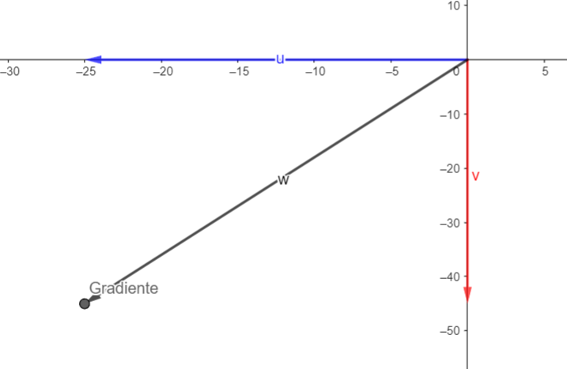
Gradient descent in a 2D cost function

Mathematical Foundations
$θ_{t+1}=θ_{t}−α∇J(θ_{t})$
Gradient descent update rule
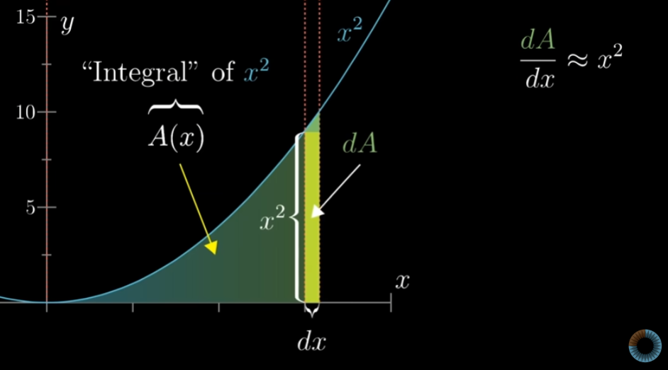
Derivative concept in gradient descent
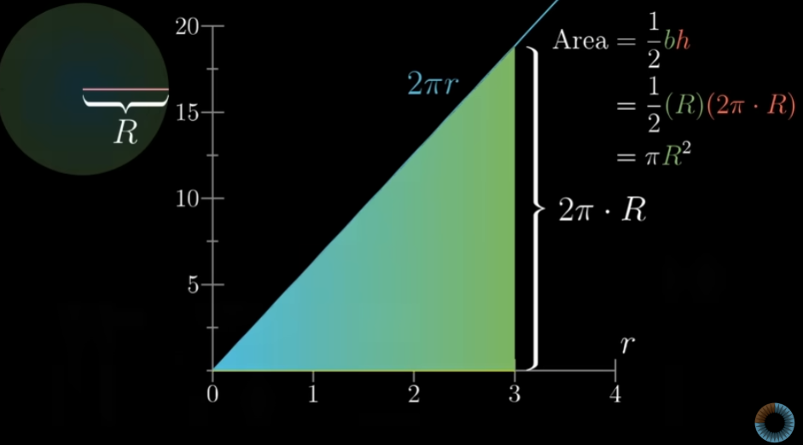
Area under the curve for integral approximation

Types of Gradient Descent
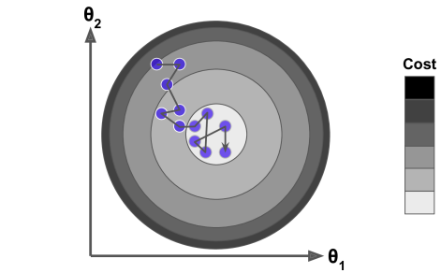
Stochastic Gradient Descent visualization
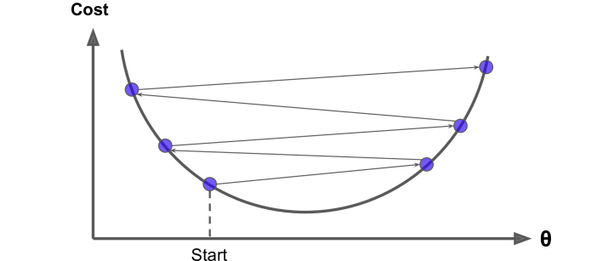
Learning rate impact on convergence
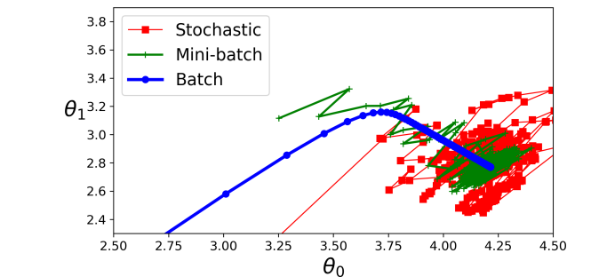
Comparison of different gradient descent methods

Common Pitfalls and Solutions
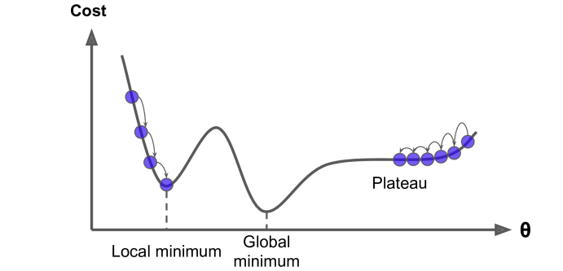
Gradient descent pitfalls like local minima
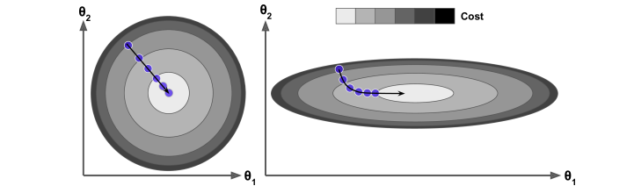
2D gradient descent with multiple features
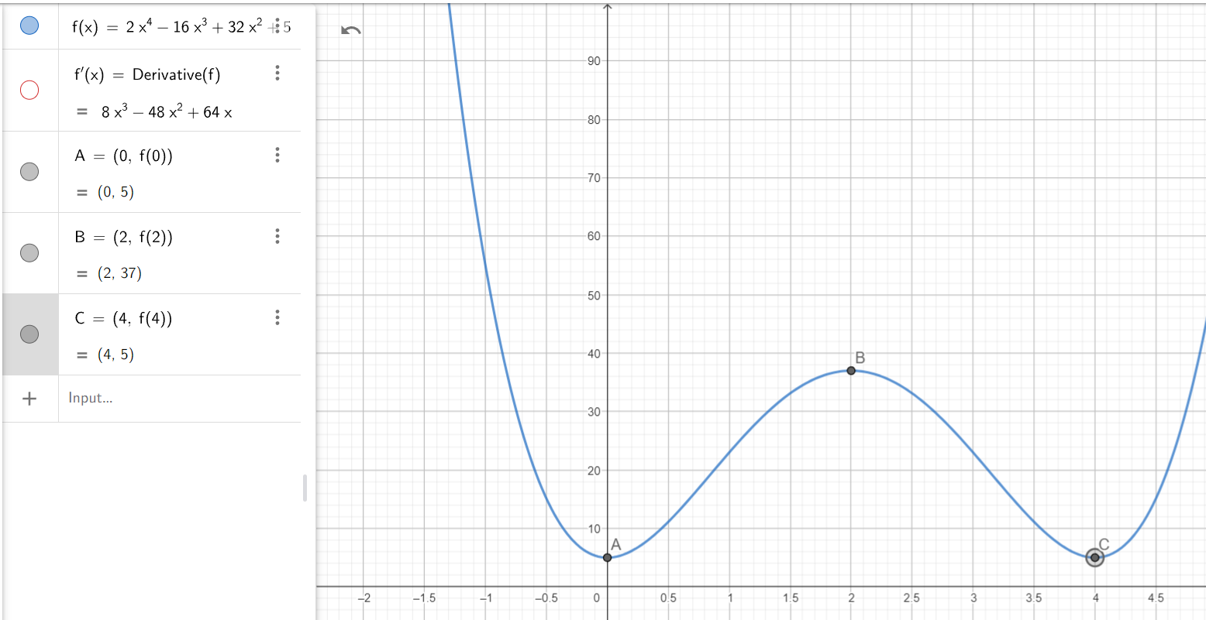
First derivative test for minima
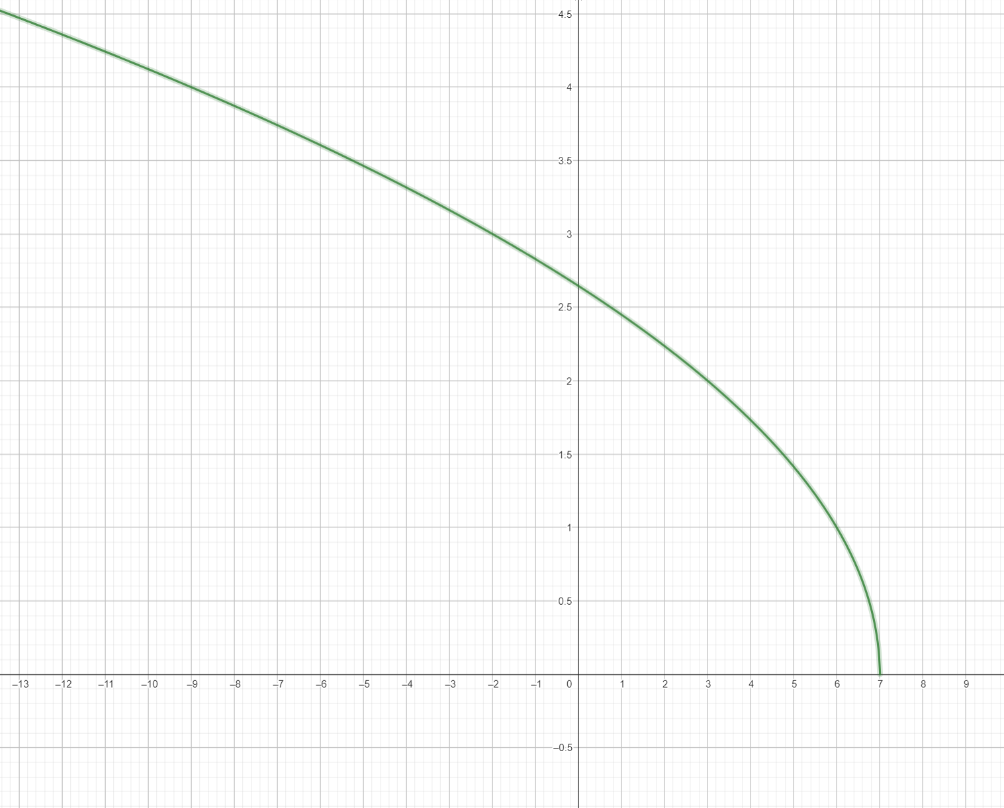
Domain of the function in gradient descent
Gradient descent is a fundamental optimization technique in machine learning. By iteratively moving in the direction of the negative gradient, it efficiently minimizes the cost function. However, careful tuning of the learning rate and understanding the landscape of the cost function are crucial for successful implementation.

